pie chart of books category zoner :

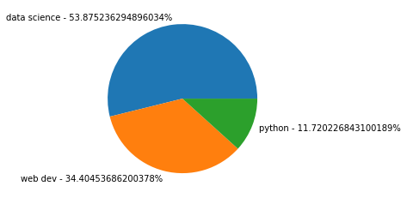

# Counting each book in bar plot (in descending order) :

# 

# Each book count in category wise by bar plot

# 

# Bar plot of top-5 books purchased by top-10 buyers

# 

# Bar plot of each book count purchased by top-10 buyers in category wise

# 

# Category wise books count purchased by top-10 buyers

